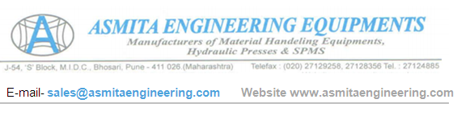
QUOTATION
To,Nihva Technologies P.Ltd. supportautomation@nihva.com Pooja-7709586333 | Quot.No. – 170725-1
 | Date – 25 July-2017

Dear Sir,
Thank you for you enquiry, we are pleased to submit our quotation for –

SPECIFICATION | HYDRAULIC PALLET TRUCK
Capacity | C | 2000kg |  | 2500kg
Overall Fork Width | W | 550 |  | 685
Fork Length | L | 1150 |  | 1220
Min Height | H1 | 90 |  | 90
Max Height | H2 | 200 |  | 200
Single Fork Width | W1 | 160 |  | 160
Wheel Dia | A,B | 180,80 |  | 180,80
Wheel Type | Nylon
BASIC PRICE | RS. 14,000/- |  | RS. 15,000/-
*Dimension Unit - All Measurements in mm
TERMS & CONDITIONS : -

TERMS & CONDITIONS : -
1. TAXES –GST@28%
2. Delivery - 1-2 days .
3. 100% Advance With Purchase Order , Against Proforma Invoice
4. Transportation and unloading to buyers accounts
5. Six Month Warranty Against Faulty Workmanship
6. If The Order Is Cancelled Payment Will Be Forfieted.
We look forward for your valued order & assure you our best service.

Thanking You,
Best Regards
For ASMITA ENGINEERING EQUIPMENTS,
Miss.-Vandana Jadhav (7720002865)



